**Final Project Report**

**Leave and attendance record system**



**Project Supervisor**

Mukaram Shah

**Submitted By**

F220206E61

Muhammad Naeem Nasir BC190402334

**Software Projects & Research Section,**

**Department of Computer Sciences,**

**Virtual University of Pakistan**

|  |
| --- |
|  |



**CERTIFICATE**

This is to certify that Muhammad Naeem Nasir (BC190402334) have worked on and completed their Software Project at Software & Research Projects Section, Department of Computer Sciences, Virtual University of Pakistan in partial fulfillment of the requirement for the degree of BS in Computer Sciences under my guidance and supervision.

In our opinion, it is satisfactory and up to the mark and therefore fulfills the requirements of BS in Computer Sciences.

**Supervisor / Internal Examiner**

Mukaram Shah

Supervisor,

Software Projects & Research Section,

Department of Computer Sciences

Virtual University of Pakistan

___________________

(Signature)

**External Examiner/Subject Specialist**

<<External Supervisor Name>>

___________________

(Signature)

**Accepted By:**

**_____________**

(For office use)

**EXORDIUM**

**In the name of Allah, the Compassionate, the Merciful.**

**Praise be to Allah, Lord of Creation,**

**The Compassionate, the Merciful,**

**King of Judgment-day!**

**You alone we worship, and to You alone we pray for help,**

**Guide us to the straight path**

**The path of those who You have favored,**

**Not of those who have incurred Your wrath,**

**Nor of those who have gone astray.**

**DEDICATION**

 I dedicate this project primarily to God Almighty my creator, my strong pillar, my source of inspiration, wisdom, knowledge and understanding. He has been the source of my strength throughout this program and on His wings only have I soared.

Secondly my efforts are dedicated to my parents Mr. and Mrs. Nasir who supported me in countless ways throughout my life. Words cannot do their efforts justice so let me conclude by a short prayer.

May God grant them the best in this world and in the Hereafter. Ameen.

**ACKNOWLEDGEMENT**

I would like to thank Virtual University of Pakistan for providing me this opportunity to hone and improve my skills. And generally to showcase my skills in an attempt to provide solutions to major problems making work environment slow and inefficient as a whole.

This project would not be possible without the help of

-Project supervisor: Mukaram Shah

-University colleagues

-Anonymous friends across the internet and countless more.

“Your help will not be forgotten. To all those who I mentioned and the ones I did not.

From the bottom of my heart, **Thank you**”.**PREFACE**

The ‘Leave and attendance record system’ is a web application created for the purpose of recording employee attendance/ leave and improve workplace efficiency. Designed, developed and completed by a Virtual university of Pakistan student named Muhammad Naeem Nasir, as a final year project. The project was started on 20 December, 2022.

I would like to thank Project Supervisor Mukaram Shah for providing helping material. Also acknowledgements to university colleagues and personal friends.

I would like to specially thank all my brothers in humanity who have uploaded tons of guide material online in a selfless act only to push the passion of programming as far as possible. This help will not be forgotten. May God grant countless blessings on everyone and anyone who helped finishing the project.

Sunday, July 30, 2023

Muhammad Naeem Nasir

**F220206E61** (BC190402334)

**TABLE OF CONTENTS**

|  |
| --- |
|  |

CHAPTER NO. 1

gathering & Analyzing info 9

1.1 Introduction …10

1.2 purpose …10

1.3 scope …11

1.4 definitions, acronyms and abbreviations …12

1.5 Project requirements …13

1.5.1 Functional Requirements …13

1.5.2 Non-Functional Requirements …14

1.6 use cases and usage scenarios …14

1.6.1 Use Case Diagrams …14

1.6.2 Usage Scenarios …15

1.7 Development Methodology …36

1.7.1 Chosen Methodology …36

1.7.2 Reasons for Chosen Methodology …37

1.7.2 Work Plan (Gantt Chart) …37

1.7.2 Project Schedule (Submission Calendar) …38

CHAPTER NO. 2

designing the project 39

2.1 Introduction …40

2.2 purpose …40

2.3 scope …40

2.4 definitions, acronyms and abbreviations …41

2.5 Architectural Representation (Architecture Diagram) …41

2.6 Dynamic Model: Sequence Diagrams …42

2.7 Object Model/Logical Model: Class Diagram …55

2.8 Database Model (Database Diagram) …57

2.9 Graphical User Interfaces …59

Chapter no.3

DEvelopment 61

3.1 Development plan (Architecture Diagram) …62

**Reference** …63

**Appendix** …64

**CHAPTER 1**

Gathering & Analyzing Info

1.1 Introduction

It all began with a problem. How do we manage the attendance/ leave of thousands of employees? And do it efficiently? This was the question that ended up being answered in the form of a web application called ‘Leave and attendance record system’. The beginning of this project consisted of gathering information about:

-the problem(s) encountered

-the piece of code being considered as the solution

-the technical limitations

-the modes of achieving the end result

-the right programming language for the task

-the chosen design

-the cost

-the participants

This was only a glimpse of the questions coming to mind of the developer Muhammad Naeem Nasir in the beginning and there were many more. To come up with an efficient solution, many phases were passed and many questions solved. These processes are documented and discussed below.

1.2 purpose

Gathering and analyzing information required for a lot of questions to be asked, like:

-What does the end product look like?

-How will the end product function?

-When will the product be completed?

-Is the project financially feasible? …etc.

It also required coming up with efficient and feasible solutions to the earlier asked questions like:

-The product should look like this.

-Product should have this/ these functionalities.

-Product can be completed around x timeframe.

-Yes, the project can be done within financial constraints

…etc.

The purpose of analyzing and gathering info is to be able to understand the core problem and related problems better. The ideas are fleshed out and presented in a visual form, sometimes to understand better, other times to support communication between designers and programmers, as well as development team and potential consumer/ client. It is a crucial process without which designing, coding, testing, maintenance is virtually impossible.

1.3 scope

The Leave and attendance record application would enable the institutional higher ups to overlook and manage institutional staff. They will be able to check, verify and control several aspects of staff's attendance, time spending and leave requests. This will create ease for employees, the managerial staff, and provide interconnectivity. They will be able to check, verify and control several aspects of staff's attendance, time spending and leave requests, creating ease for employees, the managerial staff, and provide interconnectivity.

The end users will be able to do the following:

-Login/ logout of the digital system.

-Employees will be able to apply for leave.

-Admin(s) will be able to process the leaves.

-Update their profiles.

-Admin(s) will be able to update/ delete list employees.

-Check yearly statistics about employee leaves/ attendance.

-Employees can record shift times.

Development demanded documenting earlier discussed solutions literally or graphically. The goal in the beginning was to create a piece of code that could ease/ help the whole process of registering attendance/ leave and potentially other functions. The product is to be finished in 9 months of time, minimal budget and manpower of 1 developer.

1.4 definitions, acronyms and abbreviations

1-SRS

Software Requirements Specification

2-Admin

Administrator

3-PHP

Hypertext PreProcessor. It is a general purpose scripting language geared towards web development. Used in the project in back-end.

4-SQL

Structured Query Language but pronounced as Sequel for short, is a programming language used to communicate with databases for the purpose of data storage.

5-HTML

HyperText Markup Language. It is the standard markup language for creating web-pages.

6-CSS

Cascading Style Sheets is used to specify how html pages are to be displayed in browsers or other media.

7-XAMPP

Stands for Cross-platform for Apache, MySQL, PHP and Perl. A program which is an easy to install Apache distribution containing MariaDB.

8-MySql

It is an open source relational database management system. Its name is combination of “My”, the name of co-founder Michael Wideniu’s daughter My, and “SQL”, the acronym for Structured Query Language.

9-Web Application

It is a software that runs in your web browser. Mostly used by businesses who need to exchange information and deliver services remotely and quickly.

10-App

Short for ‘Application’. It is a software program that’s designed to perform a specific function directly for the user or, in some cases, for another application program.

11-Test Cases

A test case includes information such as test steps, expected results and data.

12-Use Case diagram

Demonstrates how users might interact with the system differently.

13-Waterfall

A procedure followed by software developers to create software related products. Also referred to as linear-sequential life cycle model.

14-Gantt Chart

Commonly used graphical depiction of a project schedule.

1.5 Project requirements

1.5.1 Functional Requirements

**Employee side functional requirements**

1. Login/logout
2. Update personal profile
3. Time in/time out
4. Apply for leave
5. View Leave status
6. View total record of attendance/leave of the month/year

**Admin side functional requirements**

1. Log in/log out
2. Register new employee
3. Update/delete employee
4. Add total number of leave per year
5. Accept/reject leave request
6. Once the leave(s) is are accepted it should deducted from the leave record of an employee.
7. View attendance/leave record of an employee

1.5.2 Non-Functional Requirements

1. Adequate System Speed:

The system should perform/complete given tasks with adequate enough speed as to not make the system obsolete.

1. Robust and Reliable:

The system should be robust and reliable.

1. Secure framework:

System should have secure framework.

1. Crash immune:

System should not be subject to crashes.

1. Simple design/ interface

System should be relatively simple to use and understand.

1. Environmentally safe:

System should be not be environmentally hazardous.

1. Data integrity:

Data integrity must be maintained.

1.6 use cases and usage scenarios

1.6.1 Use Case Diagrams



1.6.2 Usage Scenarios

Test Cases

|  |
| --- |
| **Test Case** #: 1 **Test Case Name**: Login/ logout  **System**: Leave and Attendance Record System **Subsystem**: Verify entered data  **Designed by**: Naeem Nasir BC190402334 **Design Date**: 02-01-2023  **Executed by**: Naeem Nasir BC190402334 **Execution Date:** 02-02-2023  **Short Description**: The employee can log in or out of the system in order to record his attendance. |
| **Pre Conditions:**  1. Employee must have access to computer.  2. Computer must be connected to some network so entered information can be stored.  3. Employee must be registered. |
| |  |  |  |  |  | | --- | --- | --- | --- | --- | | **Step** | **Action** | **Expected System Response** | **Pass/ Fail** | **Comment** | | **1** | Employee opens the system. | System opens displaying Login screen. | Pass |  | | **2** | Employee enters Id, password. | System checks whether entered information is in valid format. | Pass |  | | **3** | Employee gains access to his/her profile. | System grants entry after checking if information matches. | Pass |  | | **4** | Employee enters wrong Id or password. | System shows error message. | Pass |  | | **5** | Employee clicks on logout option after done working. | System shows Login screen and locks out of profile. | Pass |  | |
| **Post Conditions:**  1. Employee will be able to use system and interact with his profile if correctly logged in.  2. Profile will be made inaccessible after Employee correctly logs out of the system. |

|  |
| --- |
| **Test Case** #: 2 **Test Case Name**: Update personal profile  **System**: Leave and Attendance Record System **Subsystem**: Verify and store data  **Designed by**: Naeem Nasir BC190402334 **Design Date**: 02-01-2023  **Executed by**: Naeem Nasir BC190402334 **Execution Date**: 02-02-2023  **Short Description**: Employee can choose to update his personal profile by adding new information or changing previous information. |
| **Pre Conditions:**  1. Employee must be logged in to the system. |
| |  |  |  |  |  | | --- | --- | --- | --- | --- | | **Step** | **Action** | **Expected System Response** | **Pass/ Fail** | **Comment** | | **1** | Employee clicks on update profile option. | Update profile interface opened. | Pass |  | | **2** | Employee adds requied information. | Information represented by System. | Pass |  | | **3** | Employee chooses to save/ discard changes. | System will update entered data in database. | Pass |  | | **4** | Employee exits update window. | System closes update profile tab and shows main profile interface. | Pass |  | |
| **Post Conditions:**  1. Personal profile information is changed. |

|  |
| --- |
| **Test Case** #: 3 **Test Case Name:** Time in/ time out  **System**: Leave and Attendance Record System **Subsystem**: Change option if clicked  **Designed by:** Naeem Nasir BC190402334  **Design Date**: 02-01-2023  **Executed by:** Naeem Nasir BC190402334 **Execution Date**: 02-02-2023  **Short Description**: Employee clicks on time in button to record into the system, the attendance time. Employee clicks on time out button to make the system record the end of the employee shift. |
| **Pre Conditions:**  **1.** Employee must be logged in. |
| |  |  |  |  |  | | --- | --- | --- | --- | --- | | **Step** | **Action** | **Expected System Response** | **Pass/ Fail** | **Comment** | | **1** | Employee clicks on time in button. | System stores current time and changes to time out button. | Pass |  | | **2** | Employee clicks on time out button when done. | System stores current time and changes to time in button. | Pass |  | |
| **Post Conditions:**  1. Shift beginning time as well as shift ending time is stored in the system. |

|  |
| --- |
| **Test Case** #: 4  **Test Case Name**: Apply for leave  **System:** Leave and Attendance Record System **Subsystem:** Notify admin  **Designed by**: Naeem Nasir BC190402334 **Design Date**: 02-01-2023  **Executed by:** Naeem Nasir BC190402334 **Execution Date**: 02-02-2023  **Short Description**: Employee can apply for leave which can be accepted or rejected. |
| **Pre Conditions:**  1. Employee has to be logged in to the system.  2. Employee must have enough number of leaves to apply for leave request. |
| |  |  |  |  |  | | --- | --- | --- | --- | --- | | **Step** | **Action** | **Expected System Response** | **Pass/ Fail** | **Comment** | | **1** | Employee clicks on apply for leave option. | System asks for confirmation, then sends. | Pass |  | | **2** | Employee waits until leave is checked. | Admin will be notified about leave request, he will accept, reject or leave pending. | Pass |  | | **3** | Employee closes leave request tab | System changes to main profile interface. | Pass |  | |
| **Post Conditions:**  1. Leave request registered. |

|  |
| --- |
| **Test Case** #: 5 **Test Case Name:** View leave status  **System**: Leave and Attendance Record System **Subsystem**: Leave status storage  **Designed by**: Naeem Nasir BC190402334  **Design Date**: 02-01-2023  **Executed by**: Naeem Nasir BC190402334 **Execution Date**: 02-02-2023  **Short Description**: Employee can check the leave status to see whether leave request is accepted, rejected or pending. |
| **Pre Conditions:**  1. Employee must be logged in. |
| |  |  |  |  |  | | --- | --- | --- | --- | --- | | **Step** | **Action** | **Expected System Response** | **Pass/ Fail** | **Comment** | | **1** | Employee goes to leave status section. | System opens leave status tab. | Pass |  | | **2** | Employee checks status. | System displays leave status.(accepted,  Rejected, Pending) | Pass |  | | **3** | Employee closes leave status tab. | System changes to main profile interface. | Pass |  | |
| **Post Conditions:**  In case of accepted leave, number of times employee can ask for leave is decremented.  2. In case of rejected leave, number of times employee can ask for leave remains constant. |

|  |
| --- |
| **Test Case** #: 6 **Test Case Name**: View total record of attendance / leave of the month/year  **System**: Leave and Attendance Record System **Subsystem**: Adding, storing leaves  **Designed by**: Naeem Nasir BC190402334 **Design Date**: 02-01-2023  **Executed by**: Naeem Nasir BC190402334 **Execution Date**: 02-02-2023  **Short Description**: Employee uses this option to view the total record of attendance/ leave per month or per year. |
| **Pre Conditions:**  1. Employee must be logged in to the system.  2. Employee must be registered by the administrator into the system. |
| |  |  |  |  |  | | --- | --- | --- | --- | --- | | **Step** | **Action** | **Expected System Response** | **Pass/ Fail** | **Comment** | | **1** | 1. Employee chooses option to see leave or attendance history per month. | System returns the employee’s attendance record of the requested month. | Pass |  | | **2** | Employee chooses option to see leave or attendance history per year. | System returns the employee’s attendance record of the year. | Pass |  | |
| **Post Conditions:**  1. Employee sees the presented record of his leave per month or year. |

|  |
| --- |
| **Test Case** #: 7 **Test Case Name**: Log in/ log out  **System**: Leave and Attendance Record System **Subsystem**: Verify entered information  **Designed by**: Naeem Nasir BC190402334  **Design Date**: 02-01-2023  **Executed by:** Naeem Nasir BC190402334 **Execution Date**: 02-02-2023  **Short Description**: Administrator can log in / log out of the system to oversee the activity of the employees. |
| **Pre Conditions:**  1. Administrator must have access to computer.  2. Computer must be attached to some working network so information can be stored and sent. |
| |  |  |  |  |  | | --- | --- | --- | --- | --- | | **Step** | **Action** | **Expected System Response** | **Pass/ Fail** | **Comment** | | **1** | Admin enters his Id, password. | System checks entered data’s format. | Pass |  | | **2** | Administrator presses Log in button. | System checks if entered data matches. | Pass |  | | **3** | Administrator is allowed entry. | System opens admin profile interface. | Pass |  | |
| **Post Conditions:**  1. Administrator is able to use the system.  2. Administrator is able to manage his and employee’s profile. |

|  |
| --- |
| **Test Case** #: 8 **Test Case Name**: Register new employee  **System**:Leave and Attendance Record System **Subsystem:** Store updated information  **Designed by**: Naeem Nasir BC190402334 **Design Date**: 02-01-2023  **Executed by**: Naeem Nasir BC190402334 **Execution Date**: 02-02-2023  **Short Description**: Administrator can register new employees with the system |
| **Pre Conditions:**  1. Administrator must be connected to the system.  2. Employee should have connection to the system. |
| |  |  |  |  |  | | --- | --- | --- | --- | --- | | **Step** | **Action** | **Expected System Response** | **Pass/ Fail** | **Comment** | | **1** | Administrator clicks on candidate employee. | System displays employee list. | Pass |  | | **2** | Admin clicks on register. | System changes employee status. | Pass |  | | **3** | Admin closes the tab. | System stores the decision and changes to main interface. | Pass |  | |
| **Post Conditions:**  1. Employee state changed.  2. Employee can log in to the system. |

|  |
| --- |
| **Test Case** #: 9 **Test Case Name**: Update/delete employee  **System:** Leave and Attendance Record System  **Subsystem**: Store updated status  **Designed by**: Naeem Nasir BC190402334  **Design Date**: 02-01-2023  **Executed by:** Naeem Nasir BC190402334 **Execution Date**: 02-02-2023  **Short Description**: Administrator has control over who can stay in the system. He can delete or update employee in the system. |
| **Pre Conditions:**  1. Administrator must be informed on the need of updating/ deleting of employee account. |
| |  |  |  |  |  | | --- | --- | --- | --- | --- | | **Step** | **Action** | **Expected System Response** | **Pass/ Fail** | **Comment** | | **1** | Admin opens employee list | System opens employee list tab. | Pass |  | | **2** | Admin updates/ delete employee. | System asks for confirmation, then stores updated status. | Pass |  | | **3** | Admin closes tab. | System changes to main interface. | Pass |  | |
| **Post Conditions:**  1. Employee profile is updated.  2. Employee profile is deleted. |

|  |
| --- |
| **Test Case** #: 10 **Test Case Name**: Add total number of leaves per year  **System**: Leave and Attendance Record System **Subsystem**: Storing new data  **Designed by**: Naeem Nasir BC190402334 **Design Date**: 02-01-2023  **Executed by:** Naeem Nasir BC190402334 **Execution Date**: 02-02-2023  **Short Description**: Administrator should be able to look at net amount of leave per year. |
| **Pre Conditions:**  1. Administrator must be logged into the system. |
| |  |  |  |  |  | | --- | --- | --- | --- | --- | | **Step** | **Action** | **Expected System Response** | **Pass/ Fail** | **Comment** | | **1** | Admin chooses the calculate total option. | System adds total number of leaves per year. | Pass |  | | **2** | Admin gets the processed result. | System displays the processed result. | Pass |  | | **3** | Admin backs up. | System changes to main interface. | Pass |  | |
| **Post Conditions:**  1. Administrator finds out total number of leaves per year. |

|  |
| --- |
| **Test Case** #: 11 **Test Case Name:** Accept/ reject leave request  **System**: Leave and Attendance Record System **Subsystem**: Storage of leave status  **Designed by**: Naeem Nasir BC190402334  **Design Date**: 02-01-2023  **Executed by:** Naeem Nasir BC190402334 **Execution Date**: 02-02-2023  **Short Description**: Administrator is able to accept or reject leave request requested by the employee |
| **Pre Conditions:**   1. Administrator must be logged into the system. |
| |  |  |  |  |  | | --- | --- | --- | --- | --- | | **Step** | **Action** | **Expected System Response** | **Pass/ Fail** | **Comment** | | **1** | Admin opens leave request. | System displays pending leave requests. | Pass |  | | **2** | Admin accepts, rejects or keeps it pending. | System confirms and stores decision. | Pass |  | | **3** | Admin backs up. | System changes to main interface. | Pass |  | |
| **Post Conditions:**   1. Administrator must be logged into the system |

|  |
| --- |
| **Test Case** #: 12 **Test Case Name**: Decrement leave from employee leave record if leave request accepted  **System:** Leave and Attendance Record System **Subsystem**: Storage of newly processed results  **Designed by:** Naeem Nasir BC190402334 **Design Date**: 02-01-2023  **Executed by**: Naeem Nasir BC190402334 **Execution Date**: 02-02-2023  **Short Description:** Once leave request is accepted, deduction should occur from employee’s remaining leave amount. |
| **Pre Conditions:**  1. Employee must request for leave.  2. Administrator must accept leave request. |
| |  |  |  |  |  | | --- | --- | --- | --- | --- | | **Step** | **Action** | **Expected System Response** | **Pass/ Fail** | **Comment** | | **1** | Employee requests leave and Admin accepts it. | System recognize the decision and decrements “remaining leave requests” amount. | Pass |  | | **2** |  | System also stores the newly processed results. | Pass |  | |
| **Post Conditions:**  1. Information is processed and stored.  2. Employee checks and makes informed decision. |

|  |
| --- |
| **Test Case** #: 13 **Test Case Name:** View attendance/leave record of an employee  **System:** Leave and Attendance Record System  **Subsystem:** recovering requested data  **Designed by**: Naeem Nasir BC190402334 **Design Date**: 02-01-2023  **Executed by**: Naeem Nasir BC190402334 **Execution Date**: 02-02-2023  **Short Description:** Administrator should be able to view leave record of the employees which the system will automatically store. |
| **Pre Conditions:**   1. Administrator must be logged in. |
| |  |  |  |  |  | | --- | --- | --- | --- | --- | | **Step** | **Action** | **Expected System Response** | **Pass/ Fail** | **Comment** | | **1** | Admin clicks on leave/ Attendance record. | System opens leave record interface. | Pass |  | | **2** | Admin goes back. | System changes the leave record tab to main interface. | Pass |  | |
| **Post Conditions:**  1. Administrator is informed about the statistics about employee’s attendance. |

1.7 Development Methodology

1.7.1 Chosen Methodology

Waterfall model has been chosen. It is an example of a Sequential model. In this model, the software development activity is divided into different phases and each phase consists of a series of tasks and has different objectives.

Waterfall model is the pioneer of the SDLC processes. In fact, it was the first model which was widely used in the software industry. It is divided into phases and the output of one phase becomes the input of the next phase. It is mandatory for a phase to be completed before the next phase starts. In short, there is no overlapping in the Waterfall model

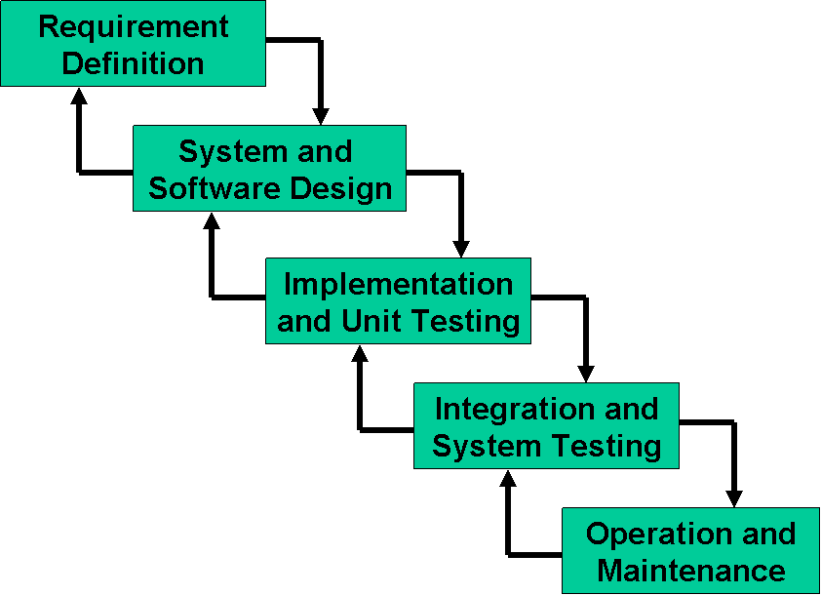

1.7.2 Reasons for Chosen Methodology  
 Waterfall model is chosen for the above application. It suggests a systematic, sequential approach to software development that begins at the system level and progresses through the analysis, design, coding, testing, and maintenance. It is chosen because it fits the system adequately. This model can be varied if need be, as the system is small enough to be supported by this kind of model. The Waterfall Model is a documentation-driven model. It therefore generates complete and comprehensive documentation and hence makes the maintenance task much easier.

1.7.2 Work Plan (Gantt Chart)

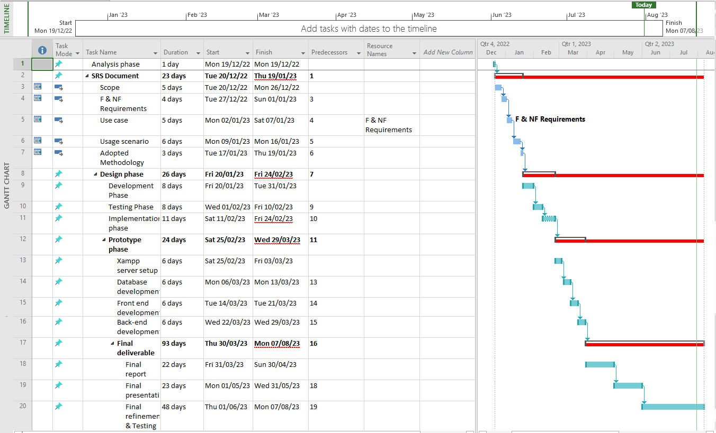

1.7.2 Project Schedule (Submission Calendar)

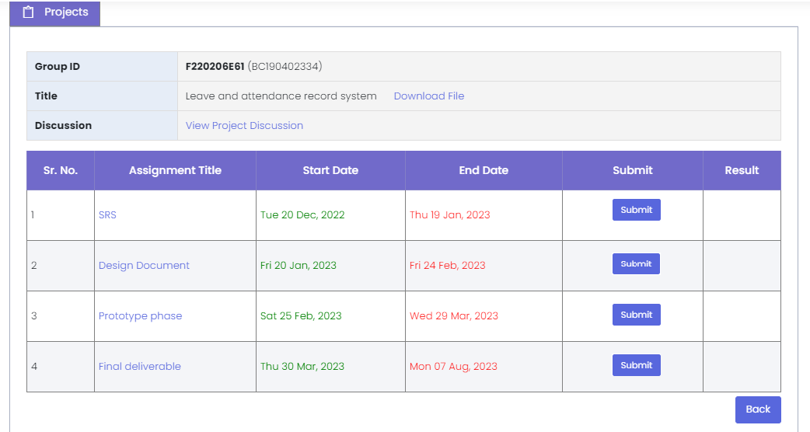

**CHAPTER 2**

Designing the Project

2.1 Introduction

The design phase of the project is where the data collected in the earlier stages is put to good use. A high level and abstract conceptual program is created with the help of editing software, word-processors, Photoshop or just free hand, which will act as a skeleton for the actual program being created. The goal is to create a set of design diagrams that explain the end product to be created inside and out. If the design is good, the end product will have huge potential. But bad design cannot be rectified in the end stages of a product life cycle no matter how many hours, capital or time is spent polishing it. Good design will also help convey the ideas of the developers to the clients/ potential customers.

2.2 purpose

The purpose of design diagrams is to explain and help understand the end product/ desired program being created. It will not only build bridges between developers and customers but also within developers themselves. It acts as a foundation for the whole program and encapsulates the functional, non-functional and business requirements of the project. A good design is an early sign of a good end product.

2.3 scope

The design process requires functional, non-functional and business requirements to be converted into visual graphs that will act as the visual constitution for the processes onwards.

The goal is to create several diagrams depicting low and high level sub-processes.

Class diagram, Database diagram, Interface diagram, Architecture diagram, ERD, Sequence diagrams and Test cases are involved in the design phase.

2.4 definitions, acronyms and abbreviations

1- ERD

Entity Relationship Diagram

2-Class diagram

It resembles a flowchart in which classes are portrayed as boxes, each box having 3 rectangles inside. Top rectangle containing class name, middle one containing attributes and bottom one containing functions.

3-Database diagram

It is an abstract graphical representation of the structure of a database.

4-Architecture diagram

A visual representation that maps out the physical implementation for components of a software system.

5-Sequence diagram

Interaction diagrams that detail how operations are carried out.

6-Interface diagram

Illustrates how end product will look like.

2.5 Architectural Representation (Architecture Diagram)



2.6 Dynamic Model: Sequence Diagrams

**Employee side functional requirements**

* + - 1. Login/logout



2. Update personal profile



3. Time in/time out



4. Apply for leave



5. View Leave status



6. View total record of attendance/leave of the month/year



**Admin side functional requirements**

7. Log in/log out



8. Register new employee:



9. Update/delete employee:



10. Add total number of leave per year



11. Accept/reject leave request



12. Once the leave(s) is are accepted it should deducted from the leave record of an employee



13. View attendance/leave record of an employee



2.7 Object Model/Logical Model: Class Diagram



2.8 Database Model (Database Diagram)



2.9 Graphical User Interfaces

Login Interface:

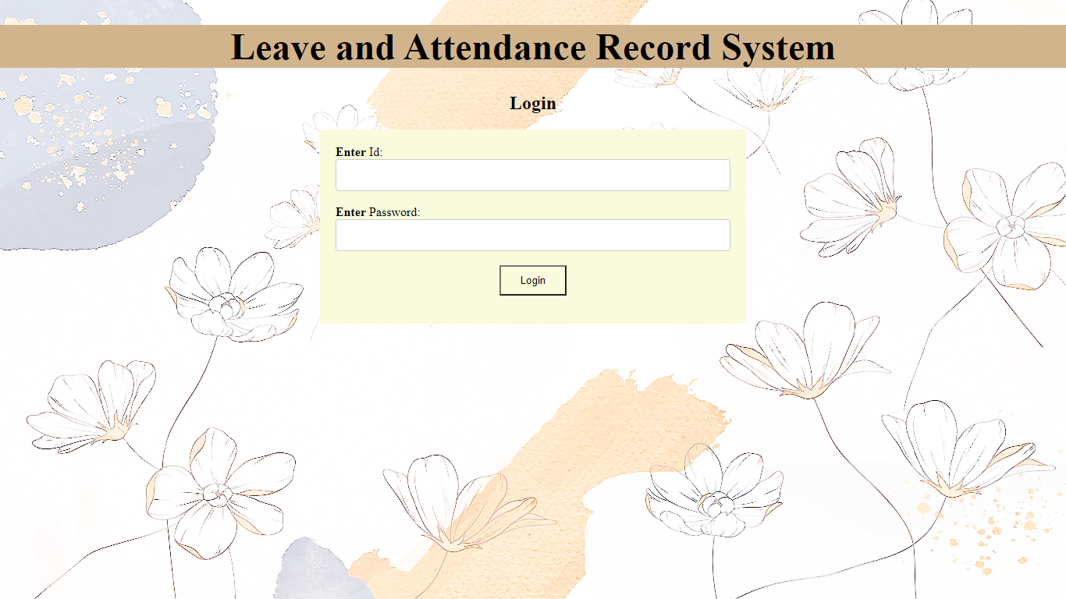

Employee Main Interface:

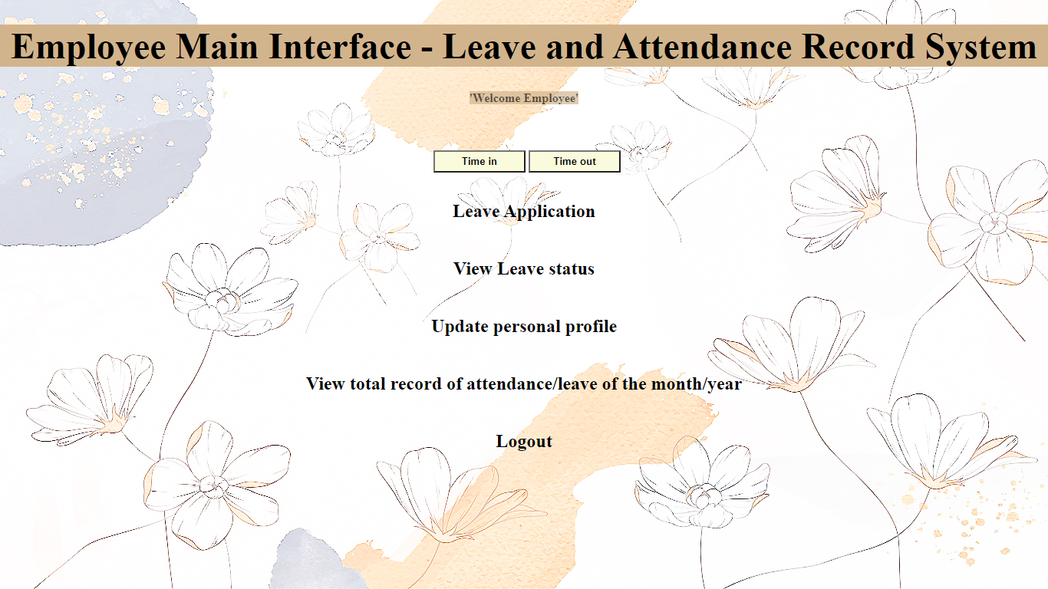

Admin Main Interface:

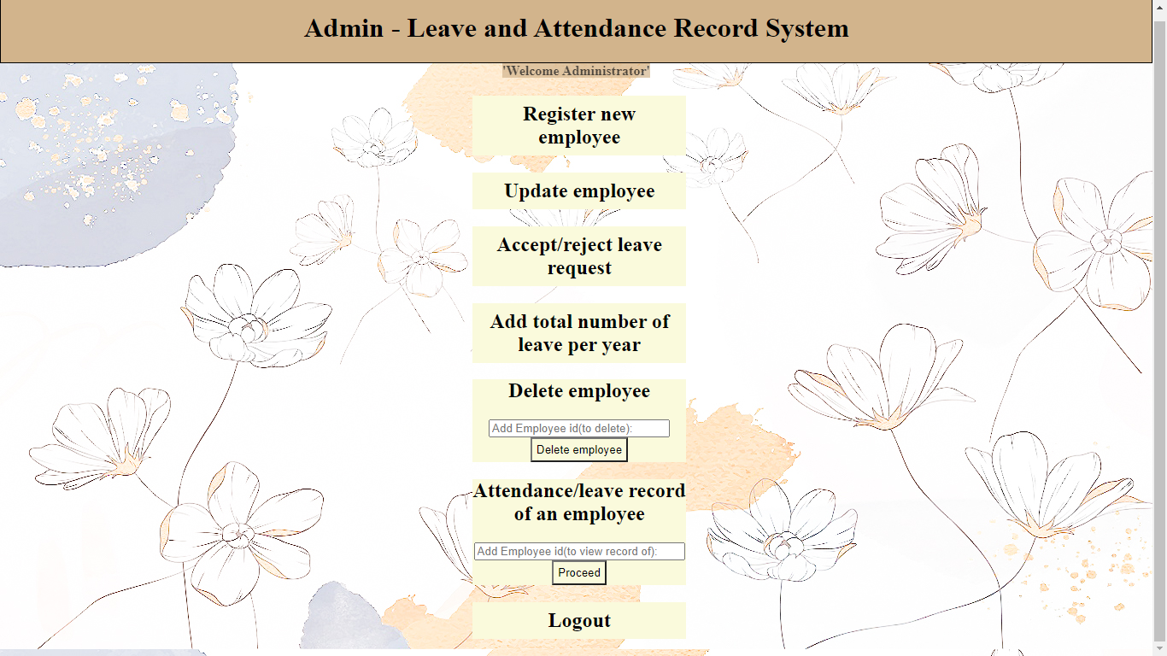

Apply for Leave Interface:

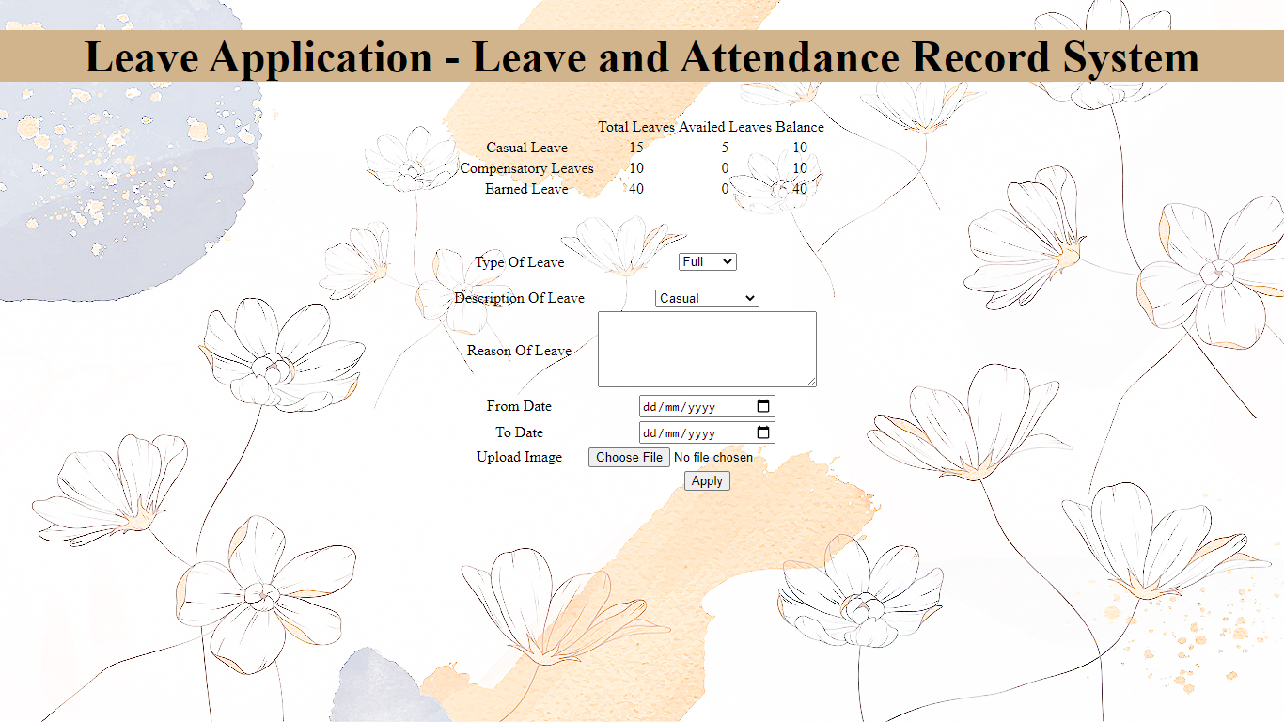

**CHAPTER 3**

Development

3.1 Development plan (Architecture Diagram)

 Normally this type of application is a 3 tier application because client, server and database are all running on separate physical devices, but our application resides on a single device, thus is a single tier application and 4 layer application.

**REFERENCES**

**Chapter 1.4:**

[PHP - Wikipedia](https://en.wikipedia.org/wiki/PHP)

[What is SQL? - Structured Query Language (SQL) Explained - AWS (amazon.com)](https://aws.amazon.com/what-is/sql/)

https://en.wikipedia.org/wiki/HTML

[CSS Introduction (w3schools.com)](https://www.w3schools.com/Css/css_intro.asp)

[Download XAMPP (apachefriends.org)](https://www.apachefriends.org/download.html)

[MySQL - Wikipedia](https://en.wikipedia.org/wiki/MySQL)

[What is a Web App? - Web Application Explained - AWS (amazon.com)](https://aws.amazon.com/what-is/web-application/) - (What is a web app?) by aws.amazon.com

[What is app? | Definition from TechTarget](https://www.techtarget.com/searchmobilecomputing/definition/app) - (What is app?) by techTarget.com

[What is a Test Case? (techtarget.com)](https://www.techtarget.com/searchsoftwarequality/definition/test-case) - (What is a Test Case?) by techTarget.com

[UML Use Case Diagram Tutorial | Lucidchart](https://www.lucidchart.com/pages/uml-use-case-diagram)

[SDLC - Waterfall Model | Tutorialspoint](https://www.tutorialspoint.com/sdlc/sdlc_waterfall_model.htm)

[Gantt chart - Wikipedia](https://en.wikipedia.org/wiki/Gantt_chart)

**Chapter 2.4:**

[What is Entity Relationship Diagram (ERD)? | Definition from TechTarget](https://www.techtarget.com/searchdatamanagement/definition/entity-relationship-diagram-ERD)

[What is a class diagram? Definition from WhatIs.com. (techtarget.com)](https://www.techtarget.com/searchapparchitecture/definition/class-diagram)

[What Is a Database Diagram? | Vertabelo Database Modeler](https://www.vertabelo.com/blog/what-is-database-diagram/)

[How to Draw 5 Types of Architectural Diagrams | Lucidchart Blog](https://www.lucidchart.com/blog/how-to-draw-architectural-diagrams)

[What is Sequence Diagram? (visual-paradigm.com)](https://www.visual-paradigm.com/guide/uml-unified-modeling-language/what-is-sequence-diagram/)

**APPENDIX**

Some useful references on the languages/ programs used in the project:

Html:

[HTML - Wikipedia](https://en.wikipedia.org/wiki/HTML)

[HTML Tutorial (w3schools.com)](https://www.w3schools.com/html/)

[HTML: HyperText Markup Language | MDN (mozilla.org)](https://developer.mozilla.org/en-US/docs/Web/HTML)

CSS:

[CSS - Wikipedia](https://en.wikipedia.org/wiki/CSS)

[CSS: Cascading Style Sheets | MDN (mozilla.org)](https://developer.mozilla.org/en-US/docs/Web/CSS)

[CSS Tutorial (w3schools.com)](https://www.w3schools.com/Css/)

PHP:

[PHP Tutorial (w3schools.com)](https://www.w3schools.com/php/default.asp)

[PHP: Hypertext Preprocessor](https://www.php.net/)

[PHP - Wikipedia](https://en.wikipedia.org/wiki/PHP)

MySQL:

[SQL - Wikipedia](https://en.wikipedia.org/wiki/SQL)

[MySQL](https://www.mysql.com/)

[MySQL - Wikipedia](https://en.wikipedia.org/wiki/MySQL)

Xampp:

[Download XAMPP (apachefriends.org)](https://www.apachefriends.org/download.html)

[XAMPP - Wikipedia](https://en.wikipedia.org/wiki/XAMPP)

[XAMPP download | SourceForge.net](https://sourceforge.net/projects/xampp/)